Distance-Time Graph Name: ___________________

Plot the information given on the graph below.

Bugsy the cockroach scurries to the right across the floor travelling 20cm in 4s. It pauses there for 3 seconds before continuing cautiously 10cm in 5s. Sensing danger, it sits still for 8s, before casually moving 15cm back the way it came in 5s.

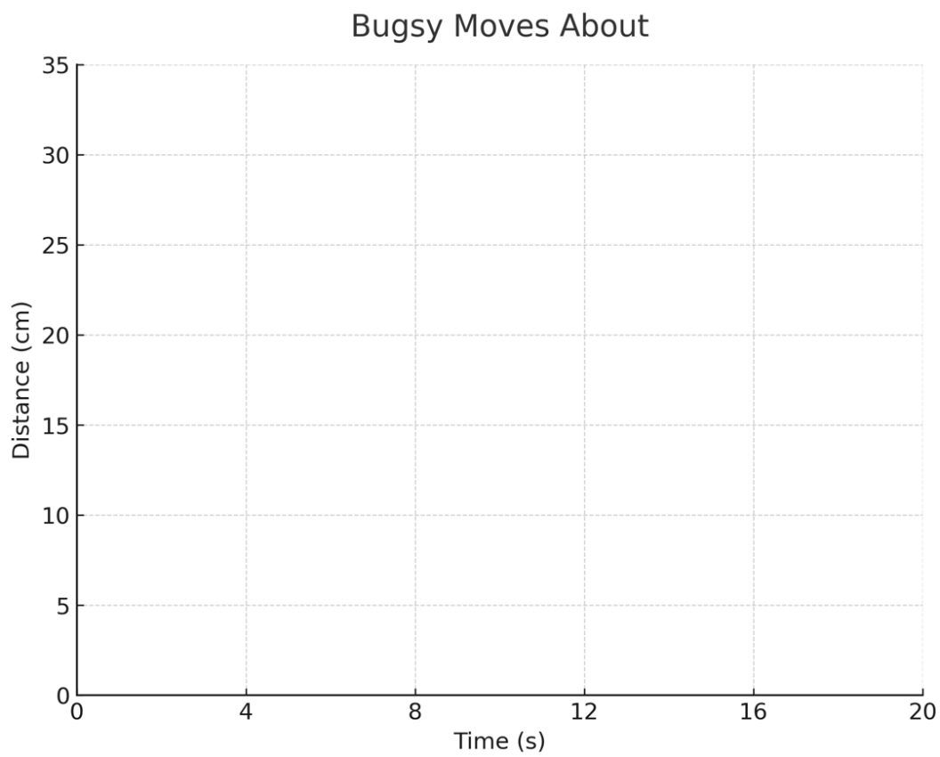
- During which time intervals is Bugsy
  - Resting

  - Moving with constant speed?

- Calculate the
  - Velocity of Bugsy during the three intervals it is moving with constant speed.

  - Average speed of Bugsy during the first 12 seconds.

  - Average velocity of Bugsy for the total time.

Velocity-Time Graph Name: ____________________

Randy drives his car down the highway, as his partner plots the following velocity-time graph of their motion:

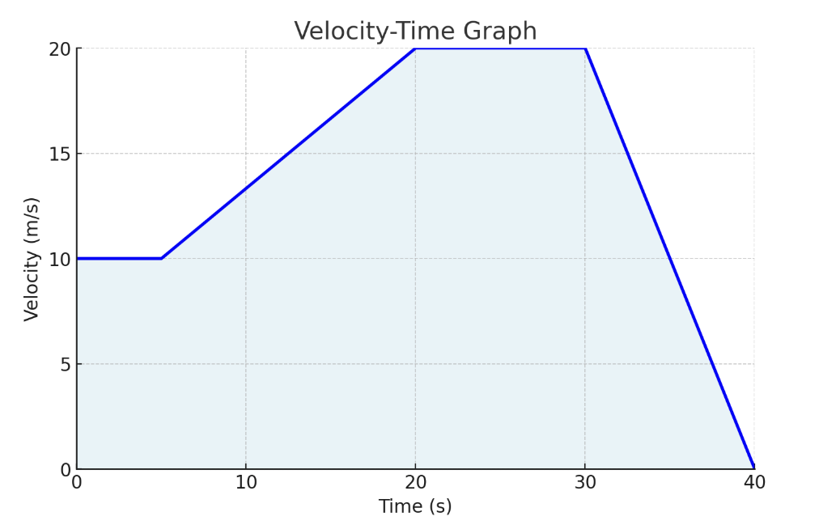

- When are they
  - Driving at constant speeds?

  - Accelerating?

  - Decelerating?

- Calculate the area of the rectangle in the graph formed by the first 5s of motion. What does the area of this rectangle represent?

- Calculate the area under the entire graph. What does this area represent?

- What is the slope of the line from t = 5s to t = 20s? What does this represent?

- What is the slope of the line from t = 30 s to t = 40s? What does this represent?

- Write a brief story that matches the motion in the graph.

