Introduction to Electrolysis
Name: ______________________ Date: _____________
Topic: Electrolysis

Section A – Key Definition
1. Define electrolysis.
Your answer must include:
- ionic compound
- molten or aqueous
- electric current
................................................................................................
................................................................................................

Section B – Understanding the Electrolytic Cell
2. Complete the sentences below:
a) The anode in an electrolytic cell is the __________ electrode.
b) The cathode in an electrolytic cell is the __________ electrode.
c) The electrolyte is the __________________________ substance that undergoes electrolysis.

Section C – Labelling a Simple Electrolytic Cell
3. A simple electrolytic cell contains:
- a power supply
- two electrodes
- an electrolyte
a) On the diagram below, label:
- Anode (+)
- Cathode (–)
- Electrolyte
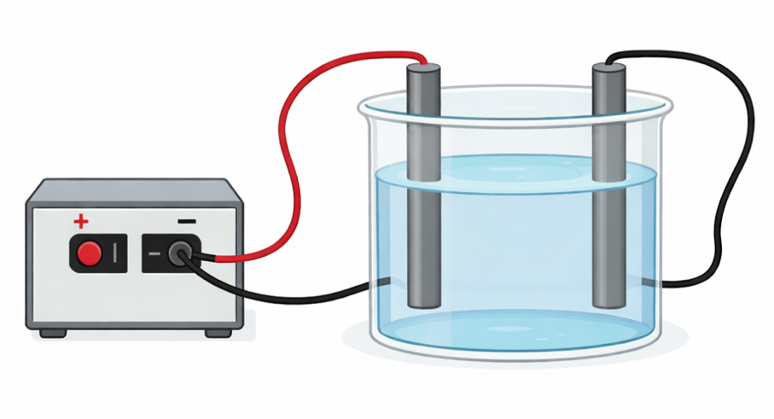
b) State the charge of:
- Anode: __________
- Cathode: __________

Section D – Identifying Components in Words
4. Read the description below and answer the questions.
A molten ionic compound is placed in a container. Two carbon electrodes are inserted and connected to a power supply. When the circuit is switched on, electrolysis begins.
a) What is the electrolyte in this setup?
................................................................................................
b) Which electrode is positive?
................................................................................................
c) Which electrode is negative?
................................................................................................

Section E – True or False
Circle True or False for each statement.
5.
a) Electrolysis can occur in solid ionic compounds. True / False
b) The anode attracts positive ions. True / False
c) The cathode is the negative electrode in electrolysis. True / False
d) The electrolyte must contain mobile ions. True / False

Section F – Explain Your Thinking
6. Explain why an ionic compound must be molten or dissolved in water for electrolysis to occur.
................................................................................................
................................................................................................

Challenge Question (Optional)
7. Describe two differences between an electrolytic cell and a simple electrical circuit (such as one with a bulb and battery).
................................................................................................
................................................................................................

Mark Scheme: Introduction to Electrolysis
(Suggested total: 20 marks)

Section A – Key Definition

1. Definition of electrolysis (3 marks)
Award:
- 1 mark for stating decomposition
- 1 mark for stating ionic compound molten or aqueous
- 1 mark for stating by the passage of an electric current
✔ Full-mark example:
Electrolysis is the decomposition of an ionic compound, when molten or in aqueous solution, by the passage of an electric current.

Section B – Understanding the Electrolytic Cell

2. Fill in the blanks (3 marks total)
a) Anode = positive (1)
b) Cathode = negative (1)
c) Electrolyte = molten or aqueous ionic substance (1)
(Accept “liquid ionic compound” or “ionic solution”)

Section C – Labelling a Simple Electrolytic Cell

3a. Diagram labels (3 marks)
- Anode labelled correctly as positive (+) (1)
- Cathode labelled correctly as negative (–) (1)
- Electrolyte labelled correctly (1)
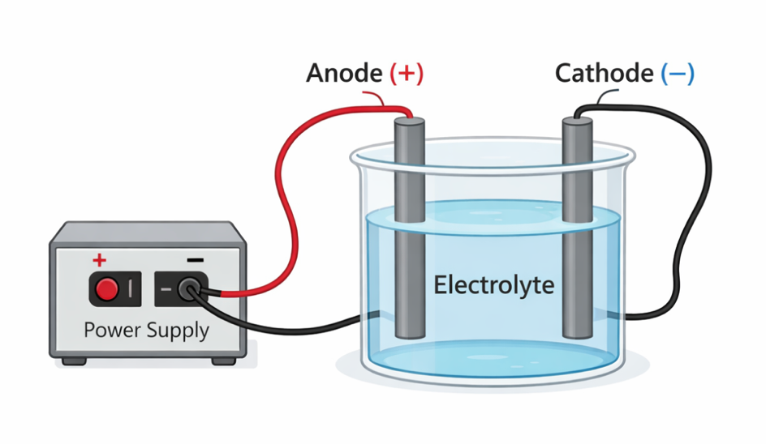

3b. Electrode charges (2 marks)
- Anode charge = positive (1)
- Cathode charge = negative (1)

Section D – Identifying Components in Words

4. Description-based questions (3 marks)
a) Electrolyte = molten ionic compound (1)
b) Positive electrode = anode (1)
c) Negative electrode = cathode (1)

Section E – True or False

5. True / False (4 marks)
a) Solid ionic compounds can be electrolysed — False (1)
b) The anode attracts positive ions — False (1)
c) The cathode is negative — True (1)
d) Electrolyte must contain mobile ions — True (1)

Section F – Explain Your Thinking

6. Why molten or aqueous? (2 marks)
Award:
- 1 mark for stating ions must be free to move
- 1 mark for stating ions are fixed in solids
✔ Example answer:
Ionic compounds must be molten or dissolved so the ions are free to move and carry charge. In a solid, the ions are fixed in place.

Challenge Question (Optional)

7. Differences between electrolytic cell and simple circuit (up to 3 marks)
Any two valid differences, 1 mark each, plus explanation if given:
- Electrolytic cell causes chemical change
- Requires ionic substance
- Uses electrodes, not components like bulbs
- Electrical circuit transfers energy without decomposition

Grade Guidance (Flexible)
- Full mastery: Correct definition + accurate electrode identification + clear explanation of ion movement
- Secure: Minor wording errors but correct concepts
- Developing: Confusion between electrode charges or electrolyte role

