Catalysts and Rates of Reaction

Part A – Understanding Catalysts
- Define a catalyst and explain how it affects the activation energy of a reaction.

- Why does lowering the activation energy increase the rate of reaction?

- Give one industrial example and one biological example of a catalyst.

Part B – Temperature, Concentration, Surface Area
- A reaction between magnesium and hydrochloric acid is carried out at 20 °C and again at 40 °C.
  - a) Which experiment is faster?

  - b) Use collision theory to explain why.

- How does increasing the concentration of a solution affect:
  - a) The frequency of particle collisions

  - b) The overall amount of product formed?

- Why does using a powdered solid instead of large chunks often make a reaction go faster?

Part C – Interpreting and Sketching Graphs
- The graph below shows the volume of gas produced against time for a reaction at two different temperatures.
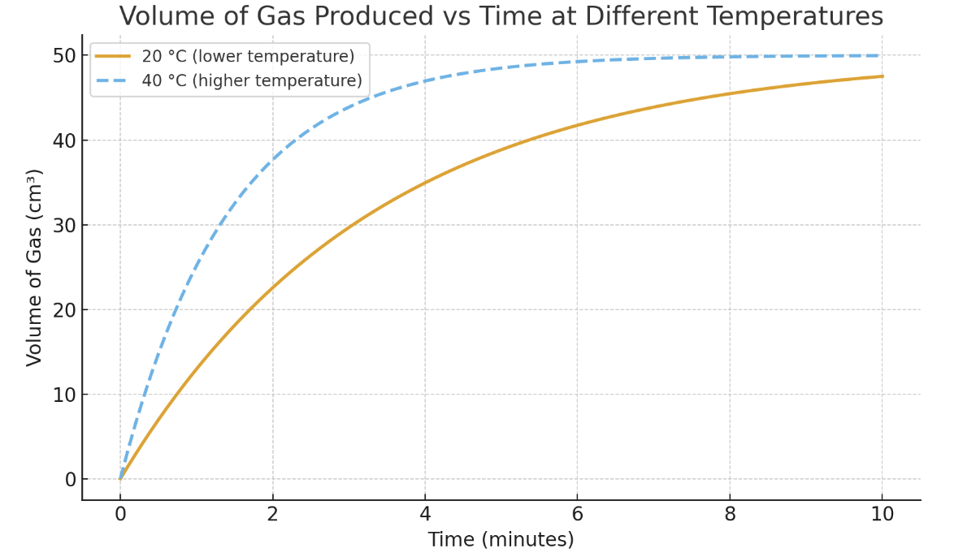
  - a) Which curve represents the higher temperature?
  - b) Explain your answer.

- Sketch a rate–time graph comparing a catalysed and an uncatalysed reaction (label both curves).
- Two reactions use the same chemicals. One has a catalyst. Describe how their initial slopes and final plateaus compare.

Part D – Mixed Reasoning
- A student wants to speed up a reaction without changing the final yield. List three changes they could make, and explain why each works.

Answer Key: Catalysts and Rates of Reaction

Part A
1. A catalyst is a substance that speeds up a reaction by providing an alternative pathway with a lower activation energy, and it remains chemically unchanged at the end.
2. Lowering the activation energy means more particle collisions have enough energy to be successful, so the reaction happens more quickly.
3. Industrial: iron in the Haber process; Biological: enzymes such as catalase.

Part B
4a. The experiment at 40 °C is faster.
4b. Heating gives particles more kinetic energy, so they collide more often and with higher energy, leading to more successful collisions.
5a. Higher concentration increases the frequency of collisions.
5b. The final amount of product is unchanged; only the speed increases.
6. Powder exposes a greater surface area, giving more particles available for collisions at once.

Part C
7a. The curve that rises steeply at first and flattens sooner is the higher temperature.
7b. A higher temperature makes collisions more frequent and energetic, so the reaction is quicker but finishes in the same total volume.
8. (Students’ sketch) – The catalysed curve should start much steeper but level out at the same height as the uncatalysed one.
9. The catalysed reaction has a steeper initial slope (faster rate) but the same final plateau (same yield).

Part D
10. Possible answers:
- Increase the temperature → particles move faster and collide with more energy.
- Increase concentration → more particles per volume, so more collisions.
- Increase surface area of solids → more exposed particles for collisions.
- Add a catalyst → lowers activation energy, giving more successful collisions.

✅ Teaching tip: For Q8, have students add arrows and labels (“activation energy barrier”) to show why the catalysed curve starts faster but ends at the same point.

