Science 9 Criterion A Name: ______________________ March 24, 2025 /50
Part 1: Multiple Choice
- Which enzyme is responsible for transcription?
  - RNA polymerase
  - Helicase
  - Ligase
  - DNA polymerase
- What is the function of a stop codon?
  - To replicate DNA
  - To signal the end of protein synthesis
  - To signal the start of protein synthesis
  - To add amino acids to a protein
- What is a codon?
  - A sequence of three nucleotides on mRNA that codes for an amino acid
  - A sequence of three amino acids in a protein
  - A protein complex in the ribosome
  - A segment of DNA that codes for tRNA
- What are the building blocks of DNA?
  - Nucleotides
  - Fatty acids
  - Amino acids
  - Proteins
- Sperm cells are specialized for:
  - Oxygen transport
  - Growth
  - Fertilization
  - Immune defense
- What is the primary waste product of the respiratory system?
  - Nitrogen
  - Water vapor
  - Oxygen
  - Carbon dioxide
- What is the primary function of the large intestine?
  - Absorbing water
  - Neutralizing stomach acid
  - Digesting fats
  - Breaking down proteins

- What is a primary component of a negative feedback loop?
  - Maintenance of balance
  - Suppression of stimuli
  - Amplification of changes
  - Disruption of stability
- Phloem cells in plants are specialized for:
  - Supporting the plant structure
  - Transporting sugars and nutrients
  - Transporting water
  - Absorbing sunlight
- Why do cells that perform high levels of activity, like neurons, have more mitochondria?
  - They synthesize more proteins
  - They store more DNA
  - They require more energy
  - They undergo more cell division
- The site of photosynthesis in plant cells is:
  - Ribosome
  - Vacuole
  - Chloroplast
  - Mitochondria
- The smooth endoplasmic reticulum is primarily responsible for:
  - Protein synthesis
  - Lipid synthesis
  - Energy production
  - DNA replication
- What hormone is released to help regulate body temperature during childbirth?
  - Oxytocin
  - Cortisol
  - Adrenaline
  - Insulin
- Shivering increases heat production in the body by:
  - Dilating blood vessels.
  - Relaxing muscles to conserve energy.
  - Enhancing blood flow to the skin.
  - Causing rapid, involuntary muscle contractions.

- Why is the predator-prey relationship considered a negative feedback system?
  - The population of predators and prey fluctuates around an equilibrium
  - Prey populations always remain constant despite predation
  - More predators always lead to prey extinction
  - Predators never depend on prey availability
- In a cold environment, which process helps reduce heat loss?
  - Vasoconstriction
  - Sweating
  - Vasodilation
  - Shivering
- What happens if we do not sleep well or eat properly?
  - The immune system stops making cells
  - The immune system gets weaker
  - The immune system ignores infections
  - The immune system works better
- What do antibodies do?
  - Attack germs and help destroy them
  - Digest food
  - Make blood flow faster
  - Stop the brain from working
- How does stomach acid help the immune system?
  - It kills harmful bacteria in food
  - It creates white blood cells
  - It carries oxygen to muscles
  - It helps the nervous system
- Why does the circulatory system need the digestive system?
  - To carry blood to the brain
  - To help break down food into nutrients like glucose
  - To help the lungs breathe better
  - To make new red blood cells

/20

Part B: Vocabulary
The smallest blood vessels, where oxygen and nutrients diffuse into cells.
A hormone that allows glucose to enter cells and helps lower blood sugar levels.
The molecule that carries genetic instructions for growth, development, and functioning in living organisms.
A harmful microorganism such as a virus, bacteria, fungus, or parasite.
The organelles known as the powerhouse of the cell, generating ATP.
Tiny air sacs in the lungs where oxygen and carbon dioxide exchange occurs.
A substitution mutation that creates a stop codon, stopping protein synthesis early.
A type of eukaryotic cell that contains a cell wall, chloroplasts, and a large vacuole.
A type of protein that helps in DNA replication, transcription, and repair.
The insulating layer around an axon that speeds up nerve impulses
The oxygen-binding protein found in red blood cells.

The cell organelle that reads mRNA and assembles amino acids into proteins.
The green pigment in chloroplasts that captures sunlight for photosynthesis.
A type of lymphocyte that includes helper and cytotoxic varieties.
The organelle that modifies, sorts, and packages proteins for transport.
A medical preparation that stimulates an immune response without causing disease.
The building block of proteins, assembled according to mRNA codons.
A long-lived immune cell that remembers past infections for a faster response.
The gel-like substance inside a cell that contains organelles.
A type of lymphocyte that produces antibodies to fight infections.

Alveoli Amino Acid B Cell Capillaries Chlorophyll
Cytoplasm DNA Enzyme Golgi Apparatus Hemoglobin
Insulin Mitochondria Plant Cell Myelin Sheath Memory B Cell
Pathogen Ribosome T Cell Vaccine Nonsense Mutation
/20
Part 3: Choose ONLY one of the following diagrams, and label the parts indicated.

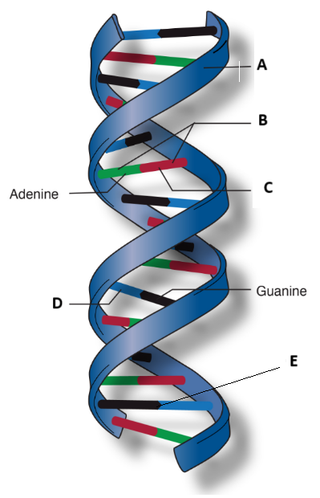 | A:  B:  C:  D:  E:

/10
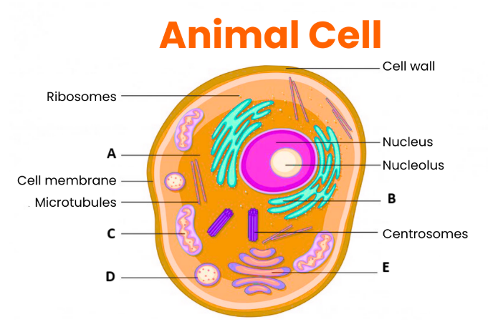 | A:  B:  C:  D:  E:

/10

