Tracing the Path of Energy in a Cell
Name: ________________________
Date: ________________________

Part 1: Multiple Choice
- Where does energy production begin in most animal cells?
A. Ribosomes
B. Mitochondria
C. Cytoplasm
D. Golgi Apparatus
- Which organelle is responsible for capturing sunlight and converting it into chemical energy in plant cells?
A. Mitochondria
B. Chloroplast
C. Ribosome
D. Lysosome
- What molecule is considered the main energy currency of the cell?
A. Glucose
B. ATP
C. Oxygen
D. DNA
- During cellular respiration, glucose is broken down into energy through which process?
A. Photosynthesis
B. Fermentation
C. Glycolysis
D. Translation
- Which of the following occurs in the mitochondria?
A. Protein synthesis
B. Glycolysis
C. ATP production through the Krebs cycle and electron transport chain
D. DNA replication

Part 2: Fill in the Blanks
- In plant cells, energy from sunlight is captured by the ____________________ during the process of _____________________.
- In the cytoplasm, glucose is broken down into smaller molecules during a process called _____________________.
- The ____________________ is known as the "powerhouse of the cell" because it produces ____________________, the cell’s energy currency.
- The high-energy molecule ____________________ is produced when energy is stored in its phosphate bonds.
- The oxygen required for cellular respiration is used in the ____________________ to maximize ATP production.

Part 3: Short Answer
- Explain how energy is transferred from glucose to ATP in animal cells. Use terms like glycolysis, mitochondria, and electron transport chain in your answer.

- Describe how the energy pathways differ between plant and animal cells. Mention chloroplasts and mitochondria in your explanation.

Part 4: Diagram Activity
Instructions: Below is a diagram of a cell with labeled organelles. Use the following steps to trace the path of energy:
- Draw and label where glucose is broken down (Glycolysis).
- Indicate the role of the mitochondria in cellular respiration.

- For plant cells, label where photosynthesis occurs.
- Use arrows to show the flow of energy from sunlight to glucose (photosynthesis) and from glucose to ATP (cellular respiration).

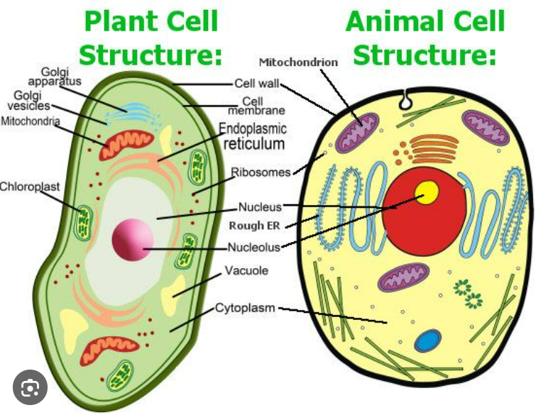

Part 5: Critical Thinking
- If the mitochondria in a cell are damaged, what impact would this have on the cell’s energy production? How might this affect the organism as a whole?

- Compare and contrast photosynthesis and cellular respiration as processes for energy transformation.

Answer Key (For Teacher Use)
Part 1:
- C
- B
- B
- C
- C
Part 2:
- Chloroplasts, photosynthesis
- Glycolysis
- Mitochondria, ATP
- ATP
- Electron transport chain
Part 3 (Sample Answers):
- Energy from glucose is first released during glycolysis in the cytoplasm, producing pyruvate. Pyruvate enters the mitochondria, where the Krebs cycle and electron transport chain convert its energy into ATP.
- Plant cells perform photosynthesis in chloroplasts to convert sunlight into glucose, which is then broken down in mitochondria to produce ATP. Animal cells lack chloroplasts and rely directly on ingested glucose for ATP production.
Part 4:
Ensure diagrams correctly show energy flow through glycolysis, mitochondria, and chloroplasts (for plants).
Part 5 (Sample Answers):
- If mitochondria are damaged, ATP production would significantly decrease, leading to energy shortages in the cell. This can impair the function of tissues and organs, especially those with high energy demands like muscles and the brain.
- Photosynthesis converts light energy into glucose in chloroplasts, while cellular respiration breaks down glucose into ATP in mitochondria. They are complementary processes, with the oxygen and glucose from photosynthesis used in cellular respiration and the carbon dioxide from respiration used in photosynthesis.

